Graphing Homework
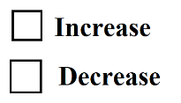  Loanable Funds Market  Real Interest Rate | 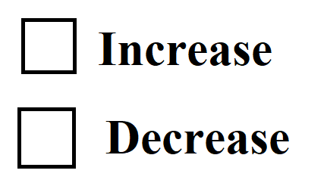  Consumption / Investment  Consumption  & Investment | AD/AS  Effect on AD (short run)?  Effect on LRAS (long run)?
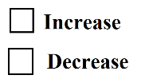  Loanable Funds Market  Real Interest Rate | Consumption/Investment  Consumption  & Investment | AD/AS  Effect on AD (short run)?  Effect on LRAS (long run)?
Show the effect on the Loanable Funds Market.
Increase in Loanable Funds Demand
Increase in Loanable Funds Supply

